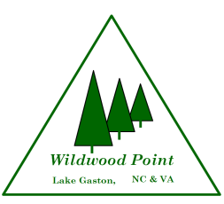
Request for Additional Wildwood Point HOA Decal 6/23
Owner(s) Name
Lot Number(s)
Date Requested
Total number of additional decals requests _______
I require the following Wildwood Point Homeowners Association Member Decals for my personal property as indicated below:
Motor Vehicle(s):
License Plate # __________________ State ____________
License Plate # __________________ State ____________
License Plate # __________________ State ____________
License Plate # __________________ State ____________

Boat(s):
Registration # ______________________________ State _______________
Registration # ______________________________ State _______________
Registration # ______________________________ State _______________
Registration # ______________________________ State _______________
This form must be filled out completely to receive additional decals.

(Property Owners signature)
Mail request to
Wildwood Point HOA/Additional Decal Request
PO Box 88 Gasburg, VA 23857

